CSA1054:SOFTWARE ENGINEERING

LAB EXPERIMENT (DAY 2)

NAME:C.GNANENDRA

REG NO:192211158

**EXPERIMENT NUMBER** 8**: Make an Online Airline Reservation System. The activities of the Online Airline Reservation system are listed below user, admin, LOGIN, MANAGE CLASSES, MANAGE WAITING LIST, MANAGE HOLDS, MANAGE DEADLINES, LOGOUT, using this has a step-by-step process draw a CLASS diagram Draw a Class diagram for Library Management System using CASE tools**

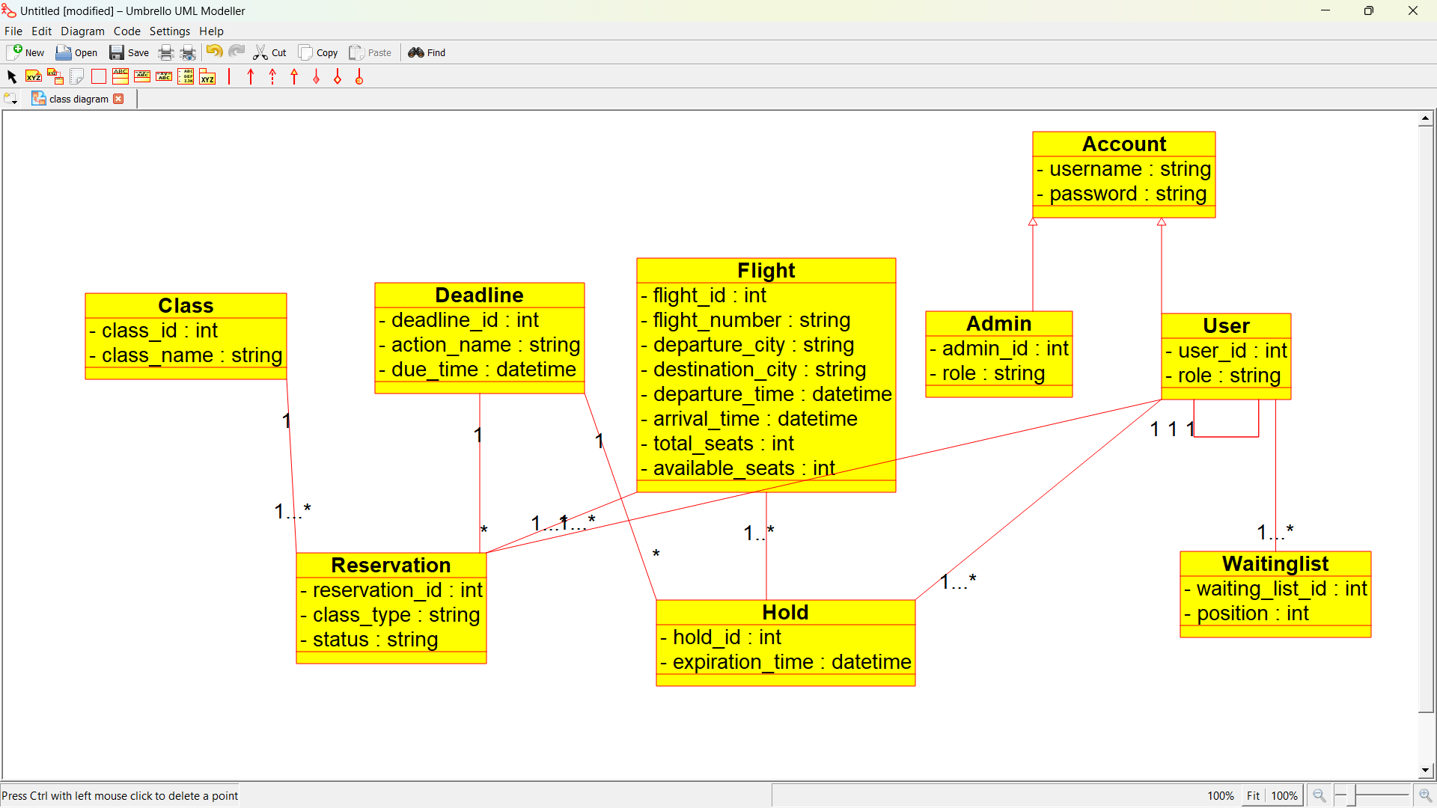

**EXPERIMENT NUMBER 9**: **Draw a Class diagram for Library Management System using CASE tools. Designing use case diagram for the library management system. User who registers himself as a new user initially is regarded as staff or student for the library system. Librarians have a key role in this system. Librarian adds the records in the library database about each student or user every time issuing the book or returning the book, or paying a fine. Design the class diagram for this**

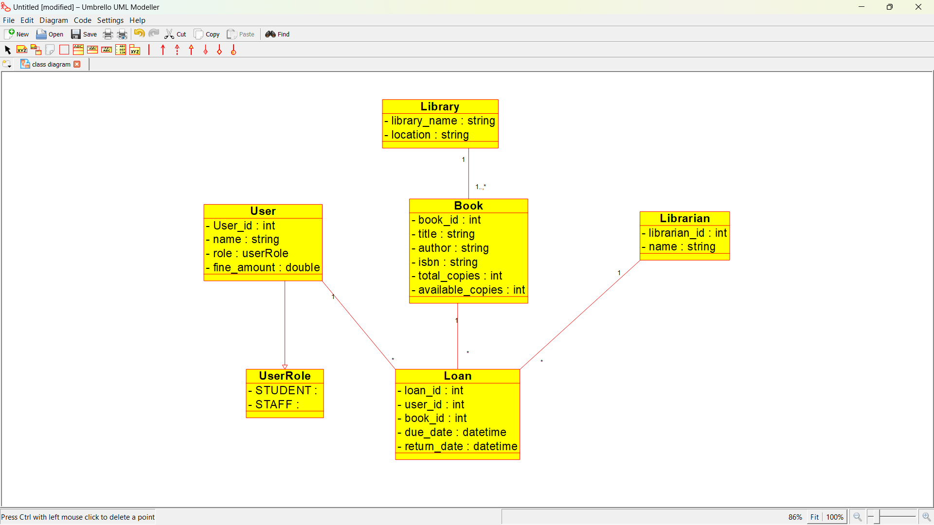

**EXPERIMENT NUMBER** 10: **Draw a Activity diagram for Online Voting System for a software platform that allows groups to securely conduct votes and elections using CASE tools. The voters should be able to register via some proper authority. Construct a system in which the voters should see the list of candidates present in his constituency. A voter should be able to cast his vote to a candidate and that voter should cast only 1 vote at a time Draw an Activity diagram for Library Management System using CASE tools.**

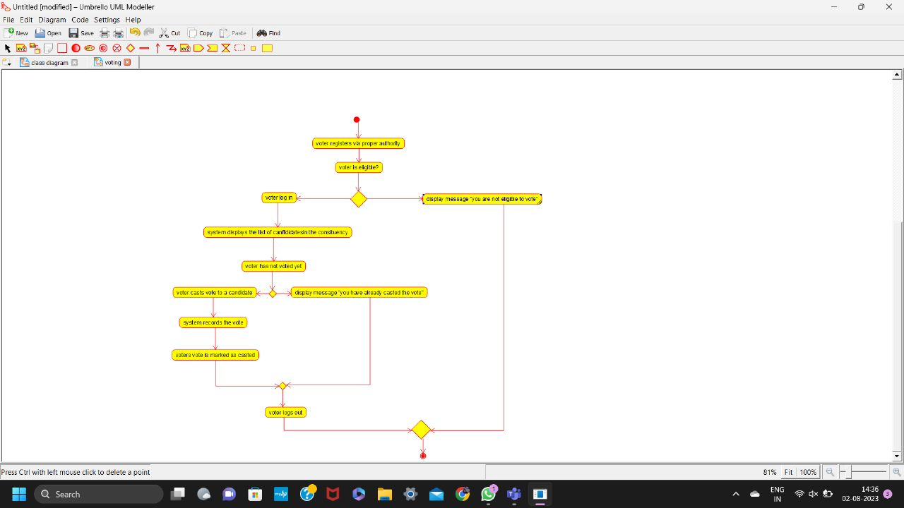

EXPERIMENT NUMBER 11**: Draw a Class diagram for Online Voting System using CASE tools. eVote is an election system that facilitates voters to record their secure and secret ballot electronically. It has a friendly user interface and enables voters to cast their votes in a few simple steps. We ensure the authenticity of the voters and the votes cast by them along with non-traceability of the casted vote elaborate the whole process of e-voting.**

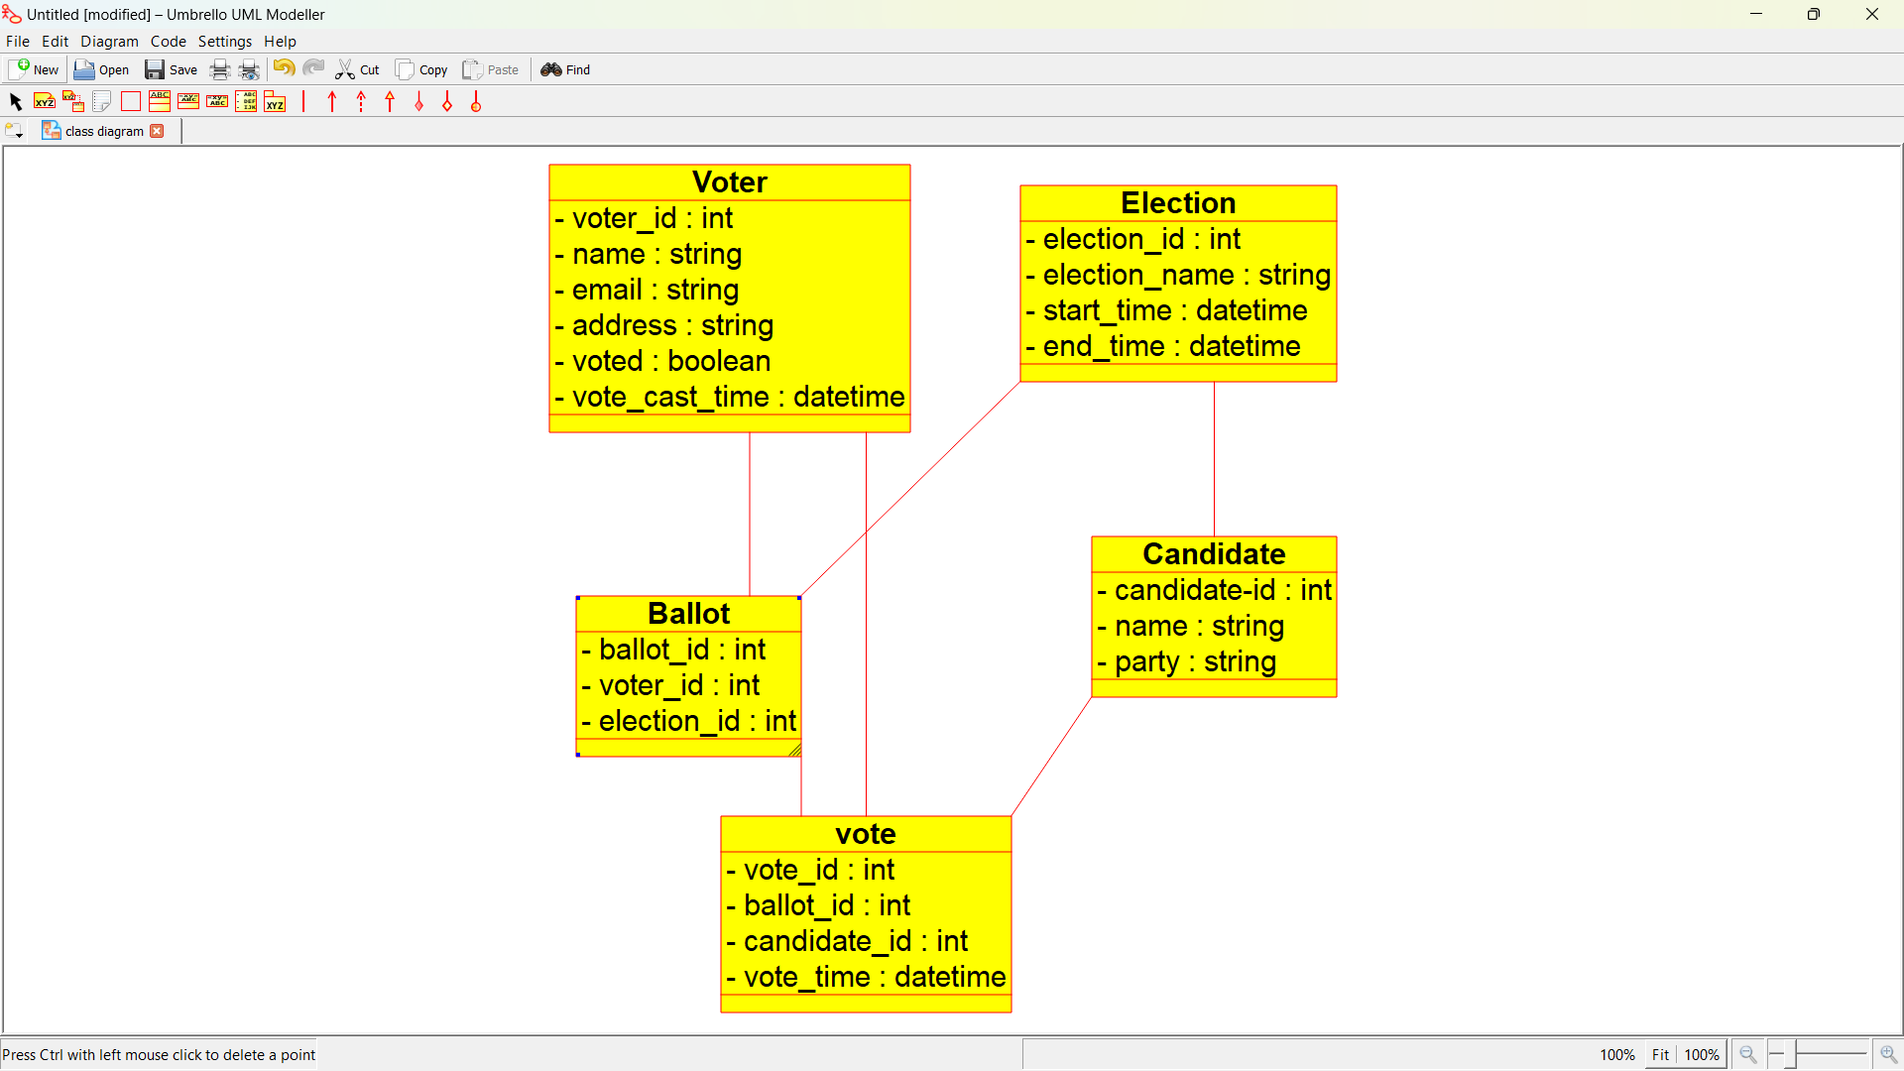

**EXPERIMENT NUMBER 12:Draw a activity diagram for library management**

